Step 1: Problem Understanding & Framing
- Frame the business and data science problem clearly.
- Define whether it's a classification, regression, recommendation, anomaly detection, or clustering task.
- Specify success metrics (e.g., Accuracy, AUC, RMSE, Silhouette Score) and business KPIs (e.g., cost savings, uplift).
- Capstone linkage: Module 1 output maps to Capstone Steps 1–3.
Deliverable: Clear problem statement + task type + target metric.
Problem Statement
E-commerce and retail companies struggle to personalize marketing efforts due to highly heterogeneous customer behaviour, leading to inefficient marketing spend and lower-than-optimal customer retention. While traditional RFM (Recency, Frequency, Monetary) identifies high-spenders, it fails to distinguish new loyalists from long-term regulars (missing Time) or capture customers willing to explore new product categories (missing Diversity).
Objective: To segment the customer base using the RFMT-D model to identify distinct behavioural groups—specifically, "high-diversity loyalists" and "at-risk long-term customers"—to enable targeted marketing campaigns that increase retention by 15% and increase cross-selling revenue within 6 months.
Task Type
- Unsupervised Learning / Clustering Analysis (using K-Means)
- Descriptive Analytics (profiling segments based on RFMT-D scores)
Target Metric
- Primary Metric: Silhouette Score and Elbow Method (SSE) to determine the optimal number of distinct clusters.
- Business Metric: Improvement in Campaign Conversion Rate (%) for targeted offers (e.g., increased conversion of "Diversity" segments to new product lines).
- Secondary Metric: Retention Rate (%) of segments classified as "At-Risk".
RFMT-D Feature Definition
- Recency: Days since the last purchase.
- Frequency: Total number of purchases.
- Monetary: Total amount spent.
- Time: Number of days between the first and last purchase.
- Diversity: Unique count of different product categories purchased.

Step 2: Data Collection & Understanding
- Use public datasets (Kaggle, UCI, APIs, etc.) or approved custom data.
- Summarise feature types, missing values, outliers, etc.
- Provide a data dictionary (variables, types, units, allowed values).
Deliverable: Dataset overview + data dictionary.
Dataset Overview
- customer_segmentation.csv (Kaggle) - The file contains all transactions occurring between 2010 and 2011of a retail store. In the dataset, there are eight columns:
Variable | Type | Description | Allowed Values | Notes
InvoiceNo | Numeric (Integer) | Invoice number composed of a 6-digit integral number uniquely assigned to each transaction. If this code starts with letter 'c', it indicates a cancellation. | 1-999999 | Alphanumeric detected
StockCode | Numeric (Integer) | Product (item) code composed of a 5-digit integral number uniquely assigned to each distinct product. | 1-99999 | Alphanumeric detected
Description | Text (String) | Product name | abc | Null value detected
Quantity | Numeric (Integer) | The quantities of each product (item) per transaction | 1-99999 | Negative value detected
InvoiceDate | Numeric | Invoice Date and time. The date and time when each transaction was generated. | MM/DD/YYYY HH:MM
UnitPrice | Numeric (Float) | Product price per unit | 1-99999 | Negative value detected
CustomerID | Numeric (Float) | Customer number composed of a 5-digit integral number uniquely assigned to each customer. | 1-99999 | Null value detected
Country | Text (String) | Country name. The name of the country where each customer resides. | abc

Findings:
- Unit price and Quantity have negative values.
- CustomerID and Description have null values.
- Some Stock Codes are not a 5-digit integral number.
- Some Stock Codes has more than one item description.
Raw Data
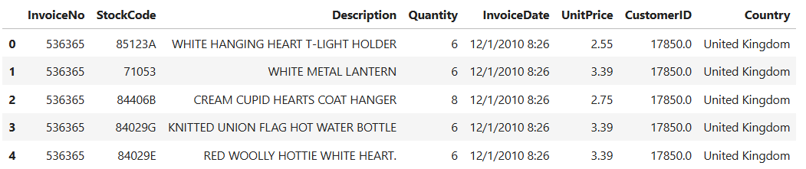
Total number of rows and columns in the dataset
Note:
For purposes of analysis, data used was filtered with Country = United Kingdom
Data Type and Non-null count
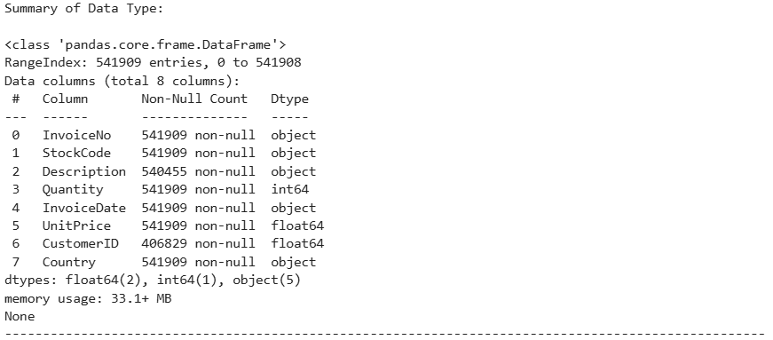
Summary statistics (for numerical data)
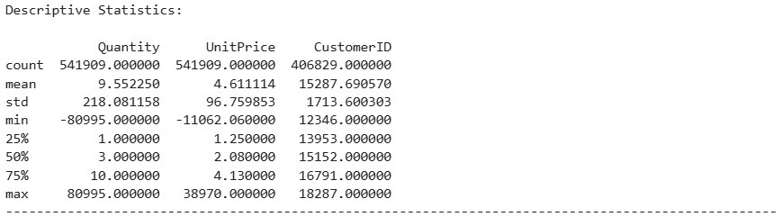

Missing values per column
Note:
Detected for columns Description and Customer ID
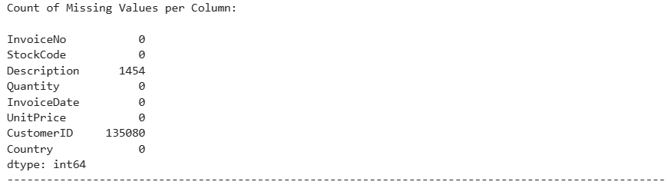
Count of invoices for each country (excerpt in descending order)
Note:
Approximately, 90% of the invoices are from the United Kingdom. Analysis was filtered and performed for the United Kingdom.


Step 3: Data Preprocessing, Applied EDA & Feature Engineering
- Clean data: Handle nulls, duplicates and outliers.
- Engineer features: Scaling, encoding, binning and domain-derived features.
- Applied EDA: Distributions, relationships, clustering tendency (if unsupervised).
- Feature importance & explainability: SHAP, LIME, or model-based importances.
- Feature selection: At least one approach (filter, wrapper, or embedded).
- Dimensionality reduction: PCA (and t-SNE/UMAP for visualisation if needed).
Deliverable: "EDA + Feature Engineering Report" with reproducible code & justifications.
Data Cleaning
The following processes were performed to clean the dataset:
- Remove rows with no CustomerID or InvoiceNo
- Remove cancelled transactions (often indicated by 'C' in InvoiceNo)
- Remove zero or negative Quantity and UnitPrice
- Convert InvoiceDate to datetime object
- Calculate TotalPrice for each transaction
- Filter only UK data which is approximately ~90% of the data
Engineer Features
A standard data preprocessing step in machine learning (using Python's scikit-learn library) was performed in order to normalize numerical data to a fixed range, 0 to 1. It prepares the RFMTD (Recency, Frequency, Monetary, Time, Diversity) features so that columns with large numbers (like Monetary) do not unfairly dominate those with small numbers (like Frequency) during modelling.
As Monetary is in the thousands (e.g., 5000) and Frequency is small (e.g., 10), algorithms like K-Means clustering will assume the Monetary column is 500 times more important. This scaling ensures every feature has an equal say.
Scaling preserves the original distribution shape of the data.
scaler = MinMaxScaler()
- What it does: Initializes the MinMaxScaler object.
- Purpose: By default, this scaler will map the minimum value in the dataset to 0 and the maximum value to 1, stretching or shrinking all other values proportionally in between.
scaler.fit_transform(...)
- What it does: This is a combination of two steps:
  - fit: The scaler scans the selected columns (Recency, Frequency, Monetary, Time, Diversity) in dataset to find the minimum and maximum values for each column individually.
  - transform: It applies the formula to every value in the columns:
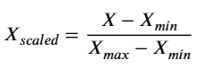
- Result: A new, scaled dataset is created, where all values in all five columns are now between 0 and 1
Applied EDA: Distributions, relationships, clustering tendency (if unsupervised).
- Visualizations (Histograms and Box plots)
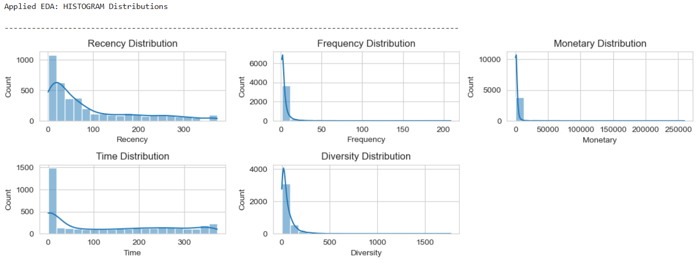
- Pair Plots
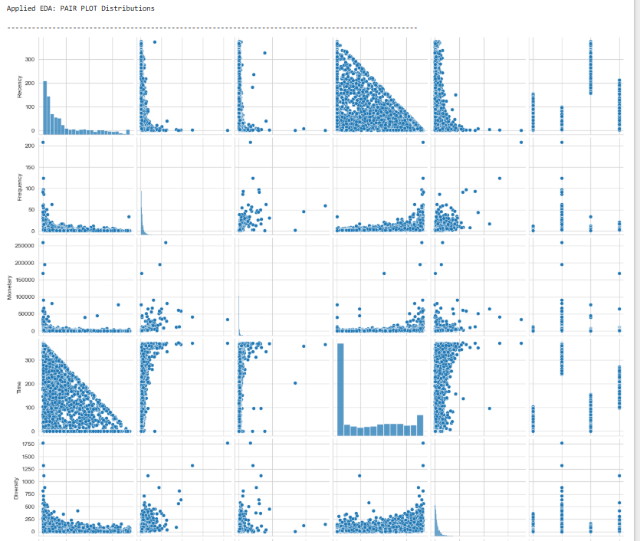

- Determining Optimal Clusters (Elbow Method and Silhouette Analysis)
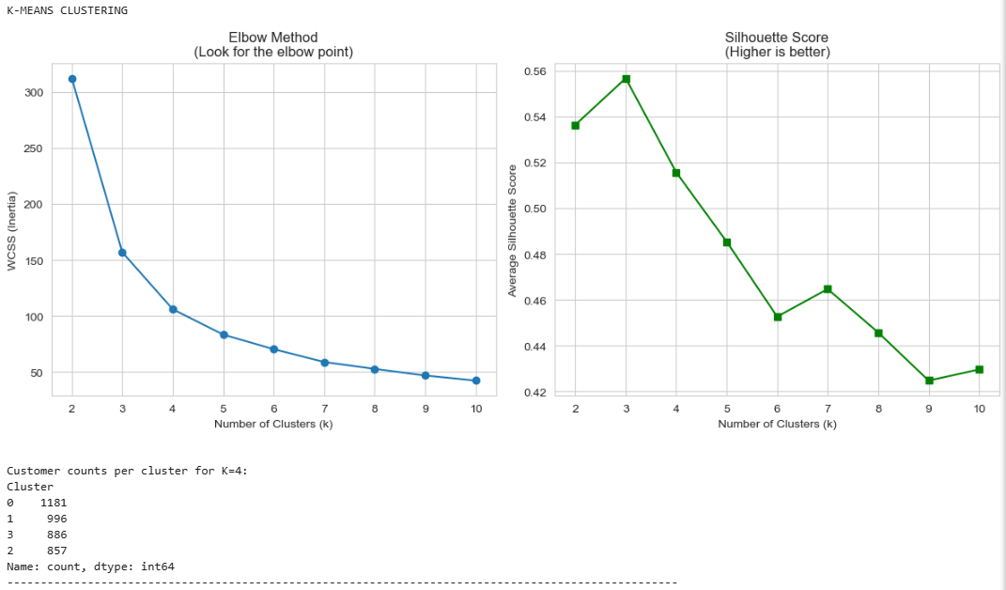

Step 4: Model Implementation
- Experiment with appropriate models:
  - Supervised: Logistic Regression, Decision Trees, Random Forest, XGBoost, SVM, etc.
  - Unsupervised: K-Means, DBSCAN, Hierarchical (Elbow, Silhouette).
  - Recommendation: Collaborative or content-based.
  - Deep Learning: RNNs, CNNs, LSTMs, Transformers (if appropriate).
- Evaluation: compare with relevant metrics.
- Reproducibility: save configs and artefacts (models/).
Deliverables: Trained models, metrics and comparison between models.
Model Comparison
For Unsupervised: K-Means, Hierarchical (Elbow, Silhouette) , DBSCAN
- K-Means
  - K-Means clustering algorithm is used to segment data into an optimal number of groups. It uses two common techniques—the Elbow Method and Silhouette Score Analysis—to determine how many clusters (k) to create, and then fits the final model.
  - For this particular dataset,
    - By looking at the plots generated, the objective is to find the point where SSE stops dropping sharply and/or where the Silhouette Score is highest. It then assigns every data point to a specific cluster (0, 1, 2, or 3).
    - The following Silhouette Scores were calculated based on the specified number of clusters (K):
      - For K=2, Silhouette Score: 0.5363473899288718
      - For K=3, Silhouette Score: 0.5570192772635395
      - For K=4, Silhouette Score: 0.5154888088574682
      - For K=5, Silhouette Score: 0.4852630441722877
      - For K=6, Silhouette Score: 0.45256929319339506
      - For K=7, Silhouette Score: 0.4645664984655552
      - For K=8, Silhouette Score: 0.44498640324102046
      - For K=9, Silhouette Score: 0.40371134417529314
      - For K=10, Silhouette Score: 0.40036607216868947
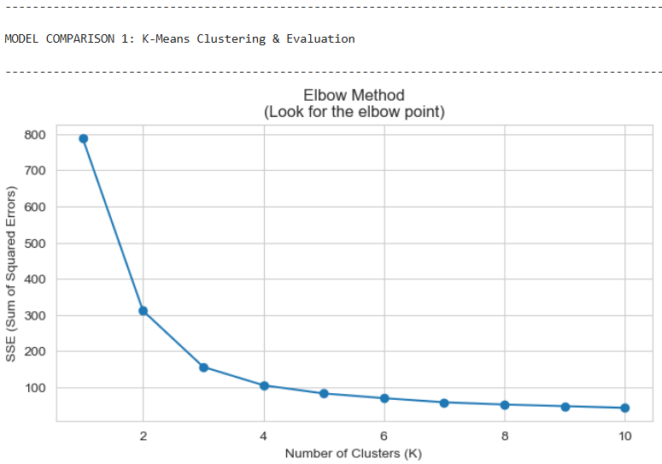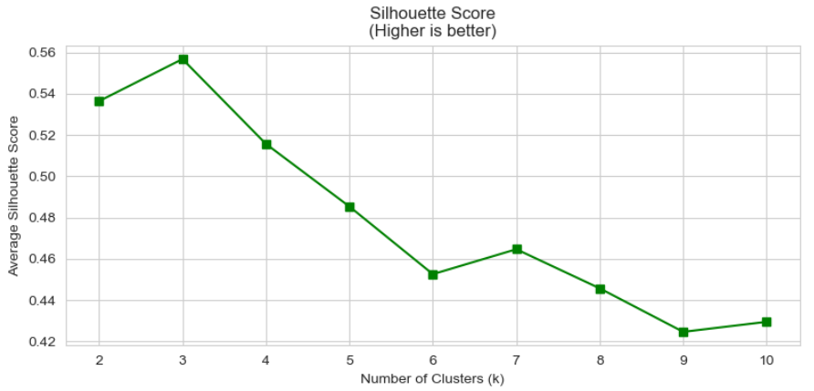
- Hierarchical (Silhouette)
  - This is an Agglomerative Hierarchical Clustering on a dataset representing customer RFMT-D data: Recency, Frequency, Monetary, Time, and Diversity and visualizes the result with a dendrogram.
  - For this particular dataset,
    - It was used to group data points into 4 distinct clusters based on their similarities, using "Ward's method" to minimize variance within the groups.
    - Hierarchical Silhouette Score: 0.49272813140867777
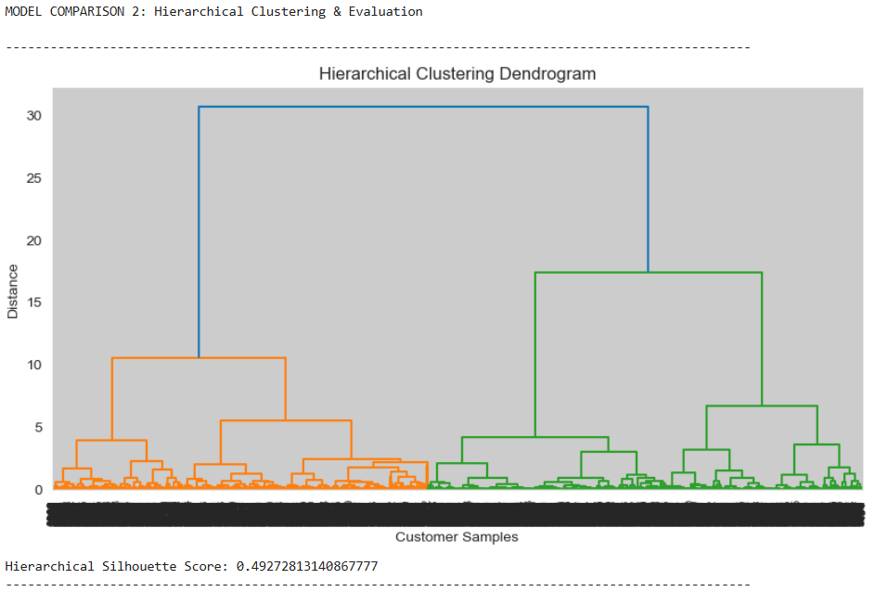
- DBSCAN
  - This is best used when the data has irregularly shaped clusters and significant noise/outliers (e.g., RFM customer segmentation), as it can find clusters of arbitrary shapes and does not require you to pre-define the number of clusters, unlike K-Means.
  - For this particular dataset,
    - DBSCAN found only one cluster or all noise points.
    - Number of DBSCAN clusters: 1
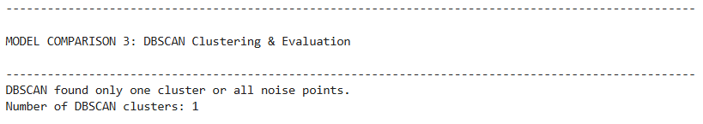

Step 5: Critical Thinking → Ethical AI & Bias Auditing
- Explain model decisions (SHAP, LIME, PDP, ICE).
- Address limitations (imbalance, leakage, overfitting).
- Bias detection & fairness audits:
  - Check outputs across sensitive groups (gender, race, age, socioeconomic status).
  - Use fairness metrics (demographic parity, equalised odds, disparate impact).
  - Propose mitigations (reweighting, thresholds, augmentation, post-processing).
Deliverable: "Bias & Fairness Analysis" section in the final report.
Performing a Critical Thinking, Ethical AI, and Bias Audit on a K-Means RFMT-D clustering model involves validating that the customer segments are not discriminatory and that the model is interpretable. In RFMT-D (Recency, Frequency, Monetary, Time and Diversity) analysis, bias often creeps in if behaviour (e.g., spending) is highly correlated with sensitive attributes like age or income, resulting in "poor" or "high-value" clusters that systematically exclude certain demographics.
For this particular dataset, there is a data limitation as attributes such as age or income is unavailable. This can be an improvement in data collection for the next analysis to be performed.
Explain Model Decisions (Interpretability)
Since K-Means is a distance-based, unsupervised algorithm, explainability focuses on understanding why a customer belongs to a cluster based on their R, F, M, T and D values.
- Feature Importance (Global): Analyse the centroids of the clusters. Use a heatmap to visualize average R, F, M, T and D values per cluster to understand what defines a "Loyal" vs. "At-Risk" group.
- SHAP/LIME (Local): For specific customers, use shap or lime libraries to explain which feature (e.g., very high frequency) pushed them into a specific cluster.
- PDP (Partial Dependence Plots): Visualize how changing a single feature (e.g., increasing Frequency) changes the probability of a customer falling into a high-value cluster.
Address Limitations
- Imbalance: If one cluster contains 90% of customers, the segmentation is not useful.
  - Solution: Experiment with different K (number of clusters) using the Elbow method or Silhouette score.
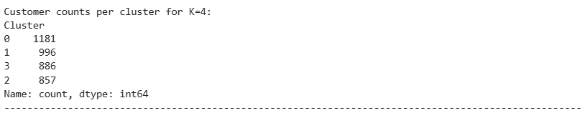
Cluster | Customer Count | Customer %
0 | 1181 | 30%
1 | 996 | 25%
3 | 886 | 23%
2 | 857 | 22%
Total | 3920 | 100%

  - For this particular dataset and analysis, all 4 clusters show approximate equal distribution.
- Data Leakage/Overfitting: If the snapshot_date (current date) is incorrect, or if future transactions are included in historical segmentation, the model is useless.
  - Solution: Use strict, consistent filtering. Do not use demographic data (age, gender) for training the clusters if the goal is purely behavioural, but it can be used for auditing.
  - For this particular dataset and analysis, future transactions are not observed in the dataset.
- Feature Scale Bias: RFMT-D metrics have different scales (e.g., Monetary can be thousands, Frequency is dozens).
  - Solution: Use StandardScaler (Z-score) or MinMaxScaler to normalize data before clustering
  - For this particular dataset and analysis, MinMaxScaler was used to normalize the data before clustering.
scaler = MinMaxScaler()
rfmtd_scaled = scaler.fit_transform(rfmtd_df[['Recency', 'Frequency', 'Monetary', 'Time', 'Diversity']])
- Bias Detection & Fairness Audits
  - Check Outputs Across Sensitive Groups: Merge the cluster labels back to the original dataset containing demographic information (gender, age, location). Calculate the composition of each cluster.
    - Example: Does "Cluster 1: High Value" have a 95% male ratio?
    - For this particular dataset, there is a data limitation as attributes such as age or income is unavailable. This can be an improvement in data collection for the next analysis to be performed.
- Fairness Metrics in Clustering:
  - Demographic Parity: Ensure the percentage of high-value customers is roughly equal across groups (e.g., % of women in "High Value" ≈ % of men).
  - Disparate Impact: Calculate ratio of favourable outcomes (high-value cluster) between groups. A ratio < 0.8 indicates bias.
    - For this particular dataset, there is a data limitation as attributes such as age or income is unavailable. This can be an improvement in data collection for the next analysis to be performed.
- Visualization: Use seaborn boxplots or violin plots to show the distribution of Monetary value across different demographic groups, faceted by Cluster.
    - For this particular dataset, there is a data limitation as attributes such as age or income is unavailable. This can be an improvement in data collection for the next analysis to be performed.
Propose Mitigations
- Reweighing/Reweighting: Assign higher weights to underrepresented groups in the high-value cluster during training.
- Threshold Adjustment: Modify the cluster centroid assignment to be more inclusive.
- Augmentation: If a certain group is missing, acquire or synthetically generate data, though this is difficult for unsupervised behaviour.
- Post-processing (Most Common): If the model is inherently biased, manually adjust the final segment definitions to remove sensitive attribute influence.

Step 6: Final Presentation & Communication
- Two deliverables for mixed audiences:
- Technical presentation (Jupyter slides / LaTeX Beamer) → peers.
- Business-facing presentation (PowerPoint / Canva) → executives (ROI, risks, strategy).
- 8–12 slides per deck recommended.
Deliverables: Two slide decks (technical + business).
Presentations
- Bernadette_Nitura_Pillar5-Capstone Project (Business).PPTX
- Bernadette_Nitura_Pillar5-Capstone Project (Technical).PPTX

Step 7: GitHub Profile & Upload
- Create a public GitHub repo structured like an Open Source project:
- Include: src/ for scripts, notebooks/, data/, models/ directories.
- Deliverables: GitHub repo link + final report + reproducible code.
- GitHub repo link: https://github.com/bnitura/Capstone-Project

- Final report:

  - Files: Bernadette_Nitura_Pillar5-Capstone Project.pdf
  - Files: Bernadette_Nitura_Pillar5-Capstone Project.docx
  - Link: https://github.com/bnitura/Capstone-Project/tree/main/models

- Reproducible code:

  - Files: Bernadette_Nitura_Pillar5-Capstone Project.ipynb
  - Link: https://github.com/bnitura/Capstone-Project/tree/main/notebooks

OPTIONAL TASKS
(Optional) Step 8: Deployment & MLOps
Complete this step if you have a good understanding of model deployment and MLOps practices.
- Local deployment (required): deploy the best model via Flask, FastAPI, or Dash.
- Optional cloud: AWS SageMaker, GCP Vertex AI, or Azure ML.
- MLOps practices:
  - Reproducible environments (requirements.txt, Docker).
  - Config-driven runs & experiment tracking (MLflow, W&B, etc.).
  - CI checks (lint, unit tests), basic monitoring plan.
  - Versioning & rollback plan.
- Provide a demo (GIF/screencast).
Deliverables: Running app + deployment guide + demo media.
(Optional) Step 9: Use of Generative AI
You may optionally use Generative AI tools to:
- Use LLMs to auto-generate EDA summaries or data dictionaries.
- Build GenAI-enhanced applications (e.g., LLM-backed recommenders, chatbots)
Deliverable:
- Document how Generative AI was used in the project
- Include code + examples in the GitHub repo or presentation
- Demo video.
Bonus points (up to +5) will be awarded for a creative and well-presented submission.

